BELO SUR MER MORONDAVA
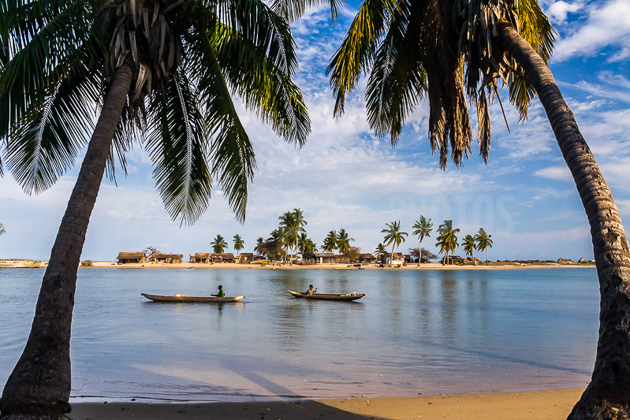

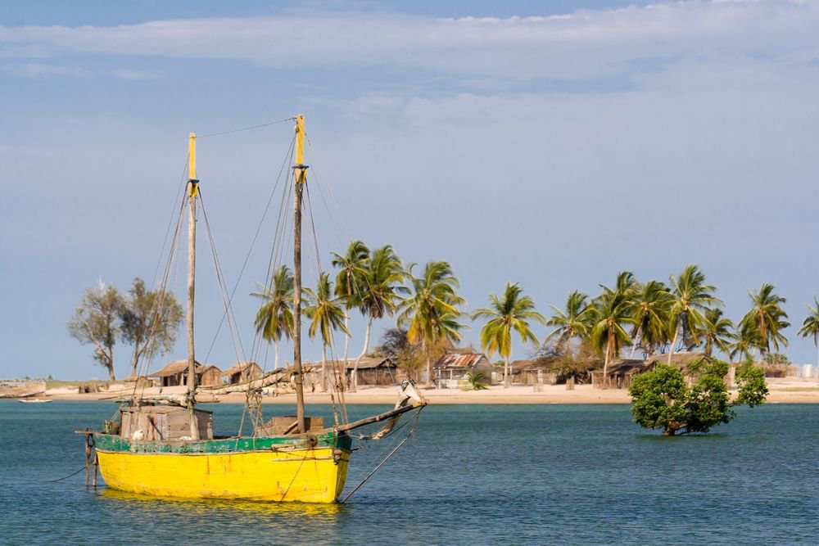
Belo sur Mer, located 80km south of the capital of Menabe (Morondava), is accessible on the ground outside the rainy season which runs from January to April. The Belo-sur-Mer peninsula presents a coastline where alternating rocks and sandy beaches offer striking contrasts with the sea that takes on every color from deep blue to translucent green.

POPULAR HOTEL:

L'Ecolodge du Menabe
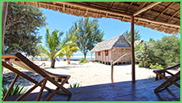
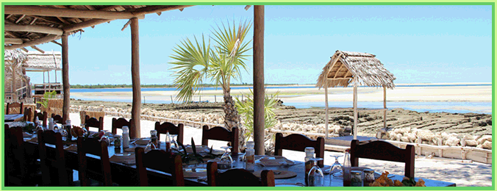
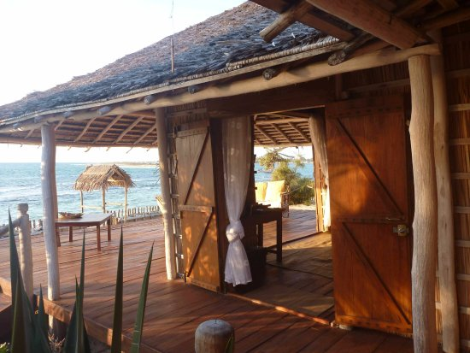
A warm decor and a functional layout: double bed (large mosquito net), bedside tables, benches, table, seats, 2 windows, French windows opening onto a terrace. Each bungalow is equipped with individual bathroom and sanitary interiors.
A simple and varied FOOD where seafood has a place of choice.
ACTIVITIES:
- VISIT THE SHIPYARD

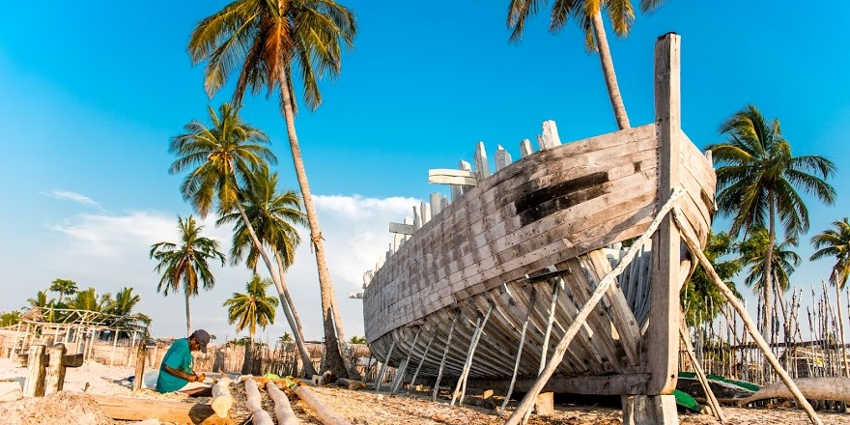

- FEATURED WALK ON MELAKY BAY

